**Video Game Analysis**

1. Are regional sales impacted by genre?

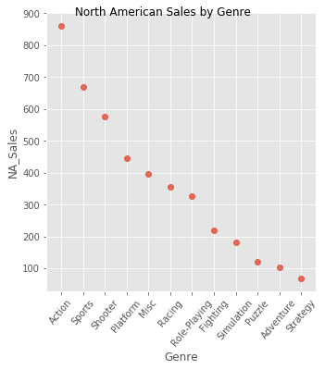We found that NA sales are driven specifically by the Action/Sports/Shooter games. We also found that Japan’s consumption of these same games is very minimal in effect as seen in the plot below.

By comparing Japan and North American sales we see that for the same genre that Japan’s consumption is far more neutral compared to the upward trend of EU and NA.

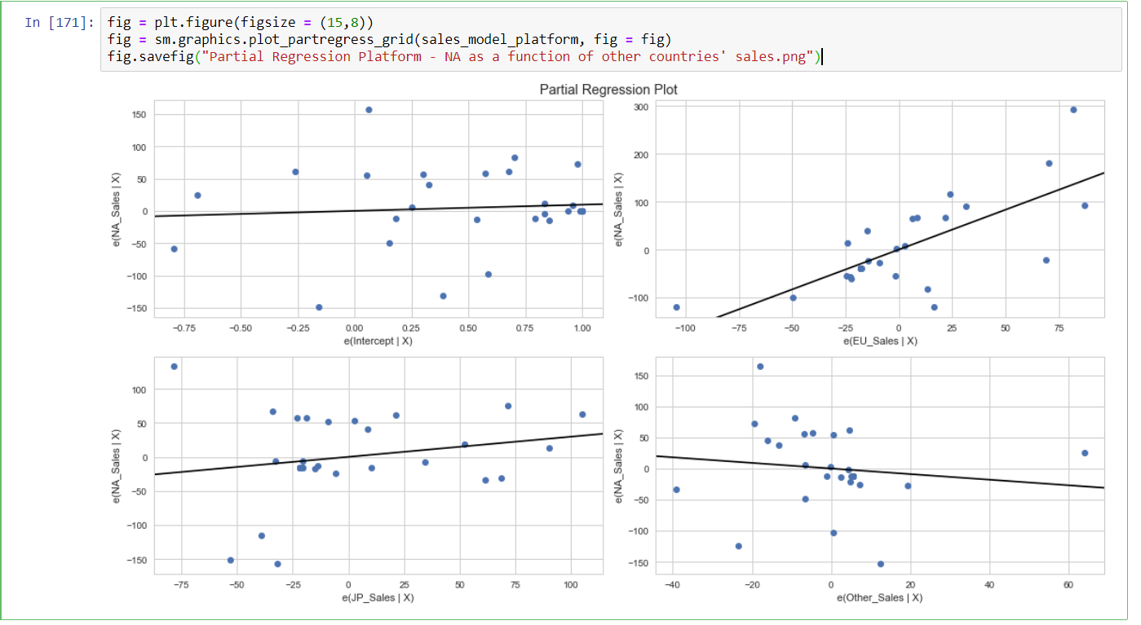

1. Does platform play a role in video game sales?

Our data as well as our supplemental sentiment analysis indicates that there is a link between platform and video game sales. The plot below indicates the number of sales are highly concentrated in the DS/PS2/PS3 market. Indicating that these platforms sold in much larger quantities than other platforms historically. Investigating the CSV we also saw that Wii Sports and Wii Sports resorts are both in the top 5 games of all time, with the Wii being one of the top 5 platforms sold.

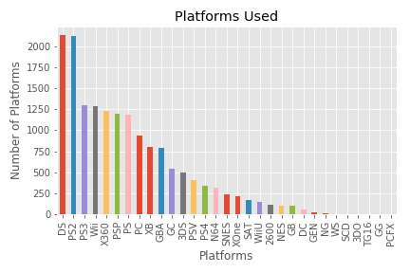

Excerpt from our statistical analysis shown below:

* Our dependent variable, North American sales; independent variables are all other countries’ sales in USD million. This data is specifically looking at Platform
* Interpreting our results:
  + Intercept $9.53 million
  + Slope for EU = 1.66; for every $1 million in EU sales, US sales will go up by $1.66 million (data set adjusts all sales to USD)
  + Slope for Japan = 0.30; for every $1 million dollars in Japanese sales, US sales for this platform will go up by ~ $296k
  + Slope for All Other Countries = -0.45; for every $1 million in sales, US sales are expected to drop by $450k. Sales cannot be negative, but our intercept (starting point) at $9.53M prevents sales being negative.
  + R-squared = 0.88: this denotes the linear relationship fits our data well

And the Twitter sentiment analysis:

* VADER sentiment analysis of tweets from the top four publishers "@PlayStation", "@Activision", "@NintendoAmerica", "@EA.” The sentiment score from the top publishers is very close in scores showing its largely positive and similar.
* Hashtag Analysis of tweets about the top video games "#Nintendo", "#PS4", "#XBone", "#Wii", "#PS3", "#DS"
* Time between tweets for the top selling Video games
* PS4 has the shortest interval between tweets of 3.5 seconds followed by Nintendo
* XBone has the highest gap between tweets followed by Wii
* VADER analysis of Tweets regarding the top selling Video games
* Average compound figure is positive for all the video games
* PS3 has the lowest compound with Wii and PS4 higher compound scores